# Analyzing Your Data

Now that your dataset is cleaned, you have reached the analysis part of the data science life cycle!

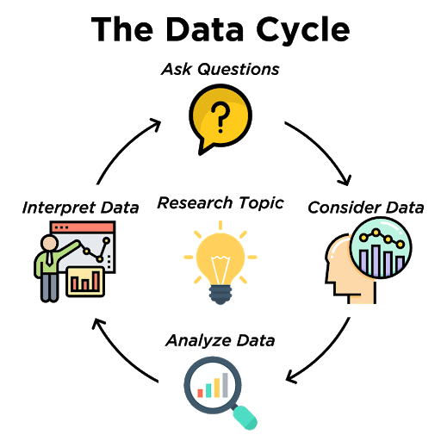

* *Analyze Data*: Perform statistical analysis, run calculations and/or create data displays to identify patterns and relationships

Data exploration and analysis is one of the most important and time-consuming steps in the data science life cycle. The goal can be to reveal something new or to find a pattern which can lead to the answer of the original statistical question.

We can use built-in functions to find the numerical summaries of the data like the measures of central tendency and measures of spread. We can also create our own functions to calculate new values using the existing data. We’ll also learn about a few more data visualizations that can be used to explore the data in the following live code video.

Happy exploring!